NORTHWIND TRADERS
Business Insight Report
Interactive Sales Dashboard — Power BI Analysis
Prepared by: | [PRAVEEN KUMAR B]
Course / Module: | [B.COM FINTECH WITH AI]
Dataset: | Northwind Traders (Power BI)
Tool Used: | Microsoft Power BI Desktop

1. Introduction
This report presents a business analysis of the Northwind Traders dataset, developed using an interactive Power BI dashboard. The Northwind Traders dataset is a classic sample database representing a specialty food import/export company, containing records of customers, orders, employees, products, and product categories.
The purpose of the dashboard is to give business stakeholders a single, interactive view of sales performance — covering order volumes, revenue by product category, freight costs, customer reach, and employee (sales representative) performance — with the ability to filter the view by Year, Region, and Category.
The purpose of this Business Insight Report is to interpret what the dashboard shows, translate the underlying observations into business insights, and recommend concrete actions for the company based on those insights.

2. Dashboard Overview

Dashboard Screenshot
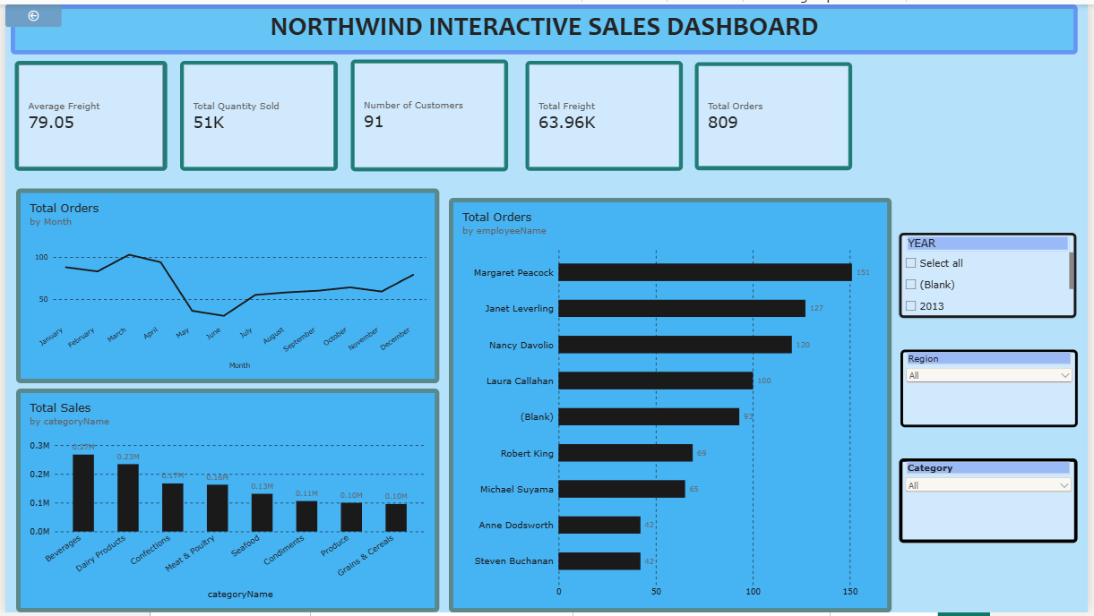
Figure 1: Northwind Interactive Sales Dashboard — full view
Purpose of the dashboard: to provide a real-time, filterable summary of Northwind Traders' sales activity so that managers can quickly identify top- and under-performing categories, employees, and time periods, and drill into the drivers of freight cost and customer reach.

Key Components
- Five KPI cards: Total Orders, Total Quantity Sold, Total Freight, Average Freight, and Number of Customers
- Total Orders by Month — line chart showing order volume trend across the year
- Total Sales by Category — clustered column chart ranking product categories by revenue
- Total Orders by Employee — clustered bar chart ranking sales staff by number of orders handled
- Number of Customers by Country — bar chart of customer distribution (supporting page)
- Product-level detail table — Total Sales and Total Quantity Sold by product, with a Category Tooltip page for drill-through

Interactive Filters Available
Students should mention:
- Year — filters the dashboard to a specific order year (2013 and Blank are the available options in this dataset)
- Region — filters all visuals by customer region
- Category — filters all visuals by product category

3. KPI Analysis

Total Orders
The dashboard records 809 total orders. This indicates the overall order activity handled by Northwind Traders across the period covered by the data — a healthy, steady volume for a mid-sized specialty distributor.

Total Quantity Sold
A total of 51,317 units (≈51K) were sold. This reflects the overall volume of product moved through the business, and — read alongside Total Orders — implies an average of roughly 63 units per order, suggesting customers typically place bulk or multi-line orders rather than single-item purchases.

Total Freight
Total freight cost across all orders is 63.96K. Relative to 809 orders, freight represents a meaningful and recurring logistics cost that scales directly with order activity.

Average Freight
The average freight cost per order is 79.05. This is the typical shipping cost the business absorbs or passes on per transaction, and is a useful benchmark for pricing, shipping-partner negotiation, and identifying unusually expensive orders.

No. of Customers
The dataset covers 91 customers. This represents the breadth of customer coverage — a relatively concentrated customer base, meaning each customer relationship carries significant weight in overall revenue.
Suggested Format
KPI | Value | Interpretation
Total Orders | 809 | Steady, healthy overall order volume for the period.
Total Quantity Sold | 51,317 (~51K) | ~63 units per order on average — customers buy in bulk / multi-line orders.
Total Freight | 63.96K | Freight is a significant, order-linked logistics cost.
Average Freight | 79.05 | Typical per-order shipping cost; useful pricing/negotiation benchmark.
No. of Customers | 91 | A relatively concentrated customer base; each account matters.

4. Product Category Performance Analysis
Students should analyse Sales by Product Category.
Discuss:
- Highest-selling category: Beverages, at approximately 0.27M in total sales — the clear revenue leader
- Lowest-selling category: Grains & Cereals, at approximately 0.10M, tied closely with Produce (also ~0.10M)
- Relative differences: Beverages outsells the lowest category (Grains & Cereals) by roughly 2.7×. Sales decline fairly steadily from Beverages (0.27M) → Dairy Products (0.23M) → Confections (0.17M) → Meat & Poultry (0.16M) → Seafood (0.13M) → Condiments (0.11M) → Produce and Grains & Cereals (~0.10M each)
- Important observations: the top two categories (Beverages and Dairy Products) together account for a disproportionate share of total category revenue, while the bottom four categories are tightly clustered, suggesting no single 'worst' category but a broad tail of moderate performers
Key Insight
Revenue is concentrated in Beverages and Dairy Products, which together outperform the rest of the catalogue. Inventory, promotions, and supplier negotiations should prioritise these two categories while monitoring the closely-bunched lower tier for opportunities to differentiate.

5. Monthly Order Trend Analysis
Students should analyse the Orders by Month chart.
Discuss:
- Highest-order month: March, at the peak of the chart (~100+ orders), following a rising trend from January
- Lowest-order month: June, at the bottom of a sharp dip (well under half of the March peak)
- Overall pattern: orders start strong and climb from January through March, then fall sharply through April–June, before recovering steadily from July through December, ending the year on an upward note
- Major fluctuations: the steep April-to-June decline is the most significant swing in the chart — order volume roughly drops by more than half in that window before recovering
Key Insight
The Jan–Mar peak followed by a sharp Apr–Jun trough points to a strong seasonal or promotional effect early in the year that is not sustained into the second quarter. The gradual H2 recovery suggests demand rebuilds steadily rather than snapping back — a pattern worth investigating (e.g., seasonal products, contract renewal cycles, or a Q1 promotion effect) and worth replicating deliberately in future years.

6. Regional / Filter-Based Analysis
Since the dashboard uses a Region slicer rather than a separate regional chart, students should demonstrate how the dashboard changes when different regions are selected. The dashboard screenshots provided show the Region slicer set to "All"; the closest available breakdown of geographic reach is the Number of Customers by Country chart, used below as a proxy for regional distribution.
Discuss:
- KPI changes — selecting a single region narrows Total Orders, Total Quantity Sold, Total Freight, Average Freight, and No. of Customers to that region only
- Category changes — the Sales by Category ranking can reorder once filtered to one region, revealing region-specific preferences
- Monthly order changes — seasonal patterns may differ by region once isolated
- Employee performance changes — some employees may be concentrated in specific regions, so the Orders by Employee ranking can shift substantially under a region filter
Suggested Format
Region | Major Observation | Business Insight
USA | Largest single customer base in the chart (13 customers), well ahead of any other single country | The USA is Northwind's anchor market and should be prioritised for account management and retention
France / Germany | Second tier, each with roughly 11 customers | Western Europe is a strong secondary market worth targeted growth campaigns
Rest of World | Long tail of 1–9 customers per country (Brazil, UK, Mexico, Spain, and many single/low-count European countries) | Reach is wide but shallow outside the top markets — an opportunity for selective expansion rather than broad investment

Supporting Visual — Customers by Country & Product Detail
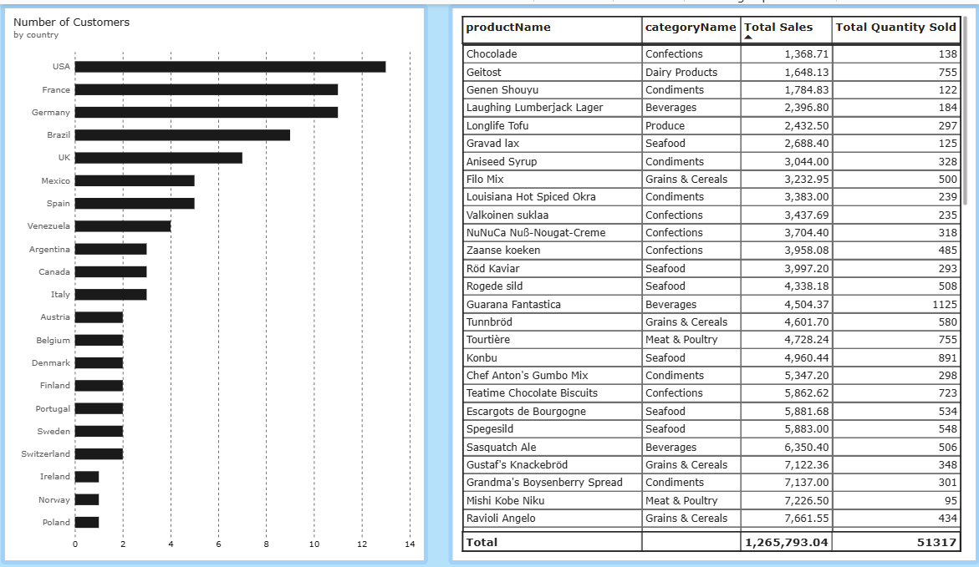
Figure 2: Number of Customers by Country, and product-level sales detail (Total: 1,265,793.04 in sales / 51,317 units across products shown)

7. Employee Performance Analysis
Students should analyse the Orders by Employee chart.
Discuss:
- Highest-performing employee: Margaret Peacock, with 151 orders — the clear top performer
- Lowest-performing employee: Steven Buchanan and Anne Dodsworth, tied at 42 orders each — the lowest named performers
- Difference between employees: a gap of 109 orders (151 vs. 42) separates the top and bottom performers — Margaret Peacock handles roughly 3.6× as many orders as Steven Buchanan or Anne Dodsworth
- Changes after applying filters: filtering by Region or Category will re-rank this chart, potentially showing that some employees specialise in particular regions or product categories rather than underperforming overall
Suggested Format
Employee | Total Orders
Margaret Peacock | 151
Janet Leverling | 127
Nancy Davolio | 120
Laura Callahan | 100
(Blank / unassigned) | 93
Robert King | 69
Michael Suyama | 65
Anne Dodsworth | 42
Steven Buchanan | 42
Key Insight
Order handling is uneven across the sales team: the top performer (Margaret Peacock) closes more than 3.5× the orders of the lowest performers. The 93 orders with no employee assigned (Blank) also warrant investigation, as they represent a data-quality or process gap worth closing.

8. Business Insights
Students should identify at least three important business insights.

Insight 1
Beverages and Dairy Products together dominate category revenue (0.27M and 0.23M respectively), while the remaining six categories are tightly clustered between 0.10M and 0.17M. Revenue is concentrated, not evenly spread, across the catalogue.

Insight 2
Order volume follows a sharp seasonal pattern — a Q1 peak in March followed by a steep trough in June — rather than a flat or gradually rising trend. Planning built on an assumed steady monthly run-rate would misjudge both staffing and inventory needs.

Insight 3
Sales performance is concentrated among a small group: 91 customers, 9 named employees, and a top-heavy country list (USA, France, Germany, Brazil) all point to a business whose results depend heavily on a relatively small set of key accounts, staff, and markets.
Observation = What the data shows
Insight = What the observation means for the business

9. Business Recommendations
Students should provide at least five recommendations.
Recommendations may relate to:
- Product category planning — protect and grow supply for Beverages and Dairy Products; assess whether Grains & Cereals and Produce need repositioning or promotion
- Inventory planning — build safety stock ahead of the Jan–Mar demand peak and scale down purchasing for the Apr–Jun trough to avoid overstock
- Regional strategy — deepen account management in the USA, France, and Germany while running low-cost, selective campaigns in long-tail countries with 1–2 customers
- Employee performance — pair lower-volume employees (e.g., Anne Dodsworth, Steven Buchanan) with the practices used by top performers like Margaret Peacock, and investigate the 93 orders with no employee assigned
- Monthly order planning — investigate the cause of the April–June dip (seasonality, contract cycles, or lapsed promotions) and pilot a targeted campaign to smooth it in the next cycle
- Freight management — use the 79.05 average freight as a benchmark to flag and review unusually costly shipments, and renegotiate carrier rates given the 63.96K total freight spend
- Customer targeting — with only 91 customers, prioritise retention and upsell programs for top accounts, since losing even a handful of customers would materially affect total revenue

10. Conclusion
Provide a brief summary of:
- Overall dashboard findings — Northwind Traders processed 809 orders and 51,317 units across 91 customers, generating 1.27M in sales, led by Beverages and Dairy Products, with a sharp Q1 peak and Q2 dip in order volume
- Most important business insight — revenue and order-handling are concentrated among a small number of top categories, employees, and markets, making the business sensitive to changes in any one of them
- Key recommendation — smooth the April–June order dip through proactive inventory and promotional planning, while continuing to prioritise the Beverages and Dairy Products categories and the USA/France/Germany markets
- How Power BI helped in the analysis — the interactive dashboard made it possible to move quickly from high-level KPIs to category-, month-, employee-, and country-level detail, and the Year/Region/Category slicers allow the same analysis to be repeated instantly for any subset of the business

